Exercise 1: Employee Management System - Overview and Setup
Business Scenario:
You are developing an employee management system that will manage employee data, departments, and their relationships.
Instructions:
- Creating a Spring Boot Project:
  - Initialize a new Spring Boot project named EmployeeManagementSystem.
  - Add dependencies: Spring Data JPA, H2 Database, Spring Web, Lombok.
- Configuring Application Properties:
  - Configure application.properties for H2 database connection.
spring.datasource.url=jdbc:h2:mem:testdb
spring.datasource.driverClassName=org.h2.Driver
spring.datasource.username=sa
spring.datasource.password=password
spring.jpa.database-platform=org.hibernate.dialect.H2Dialect

Output:
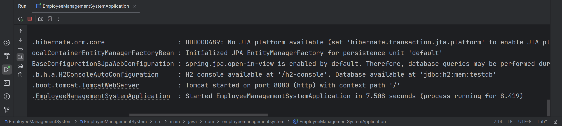
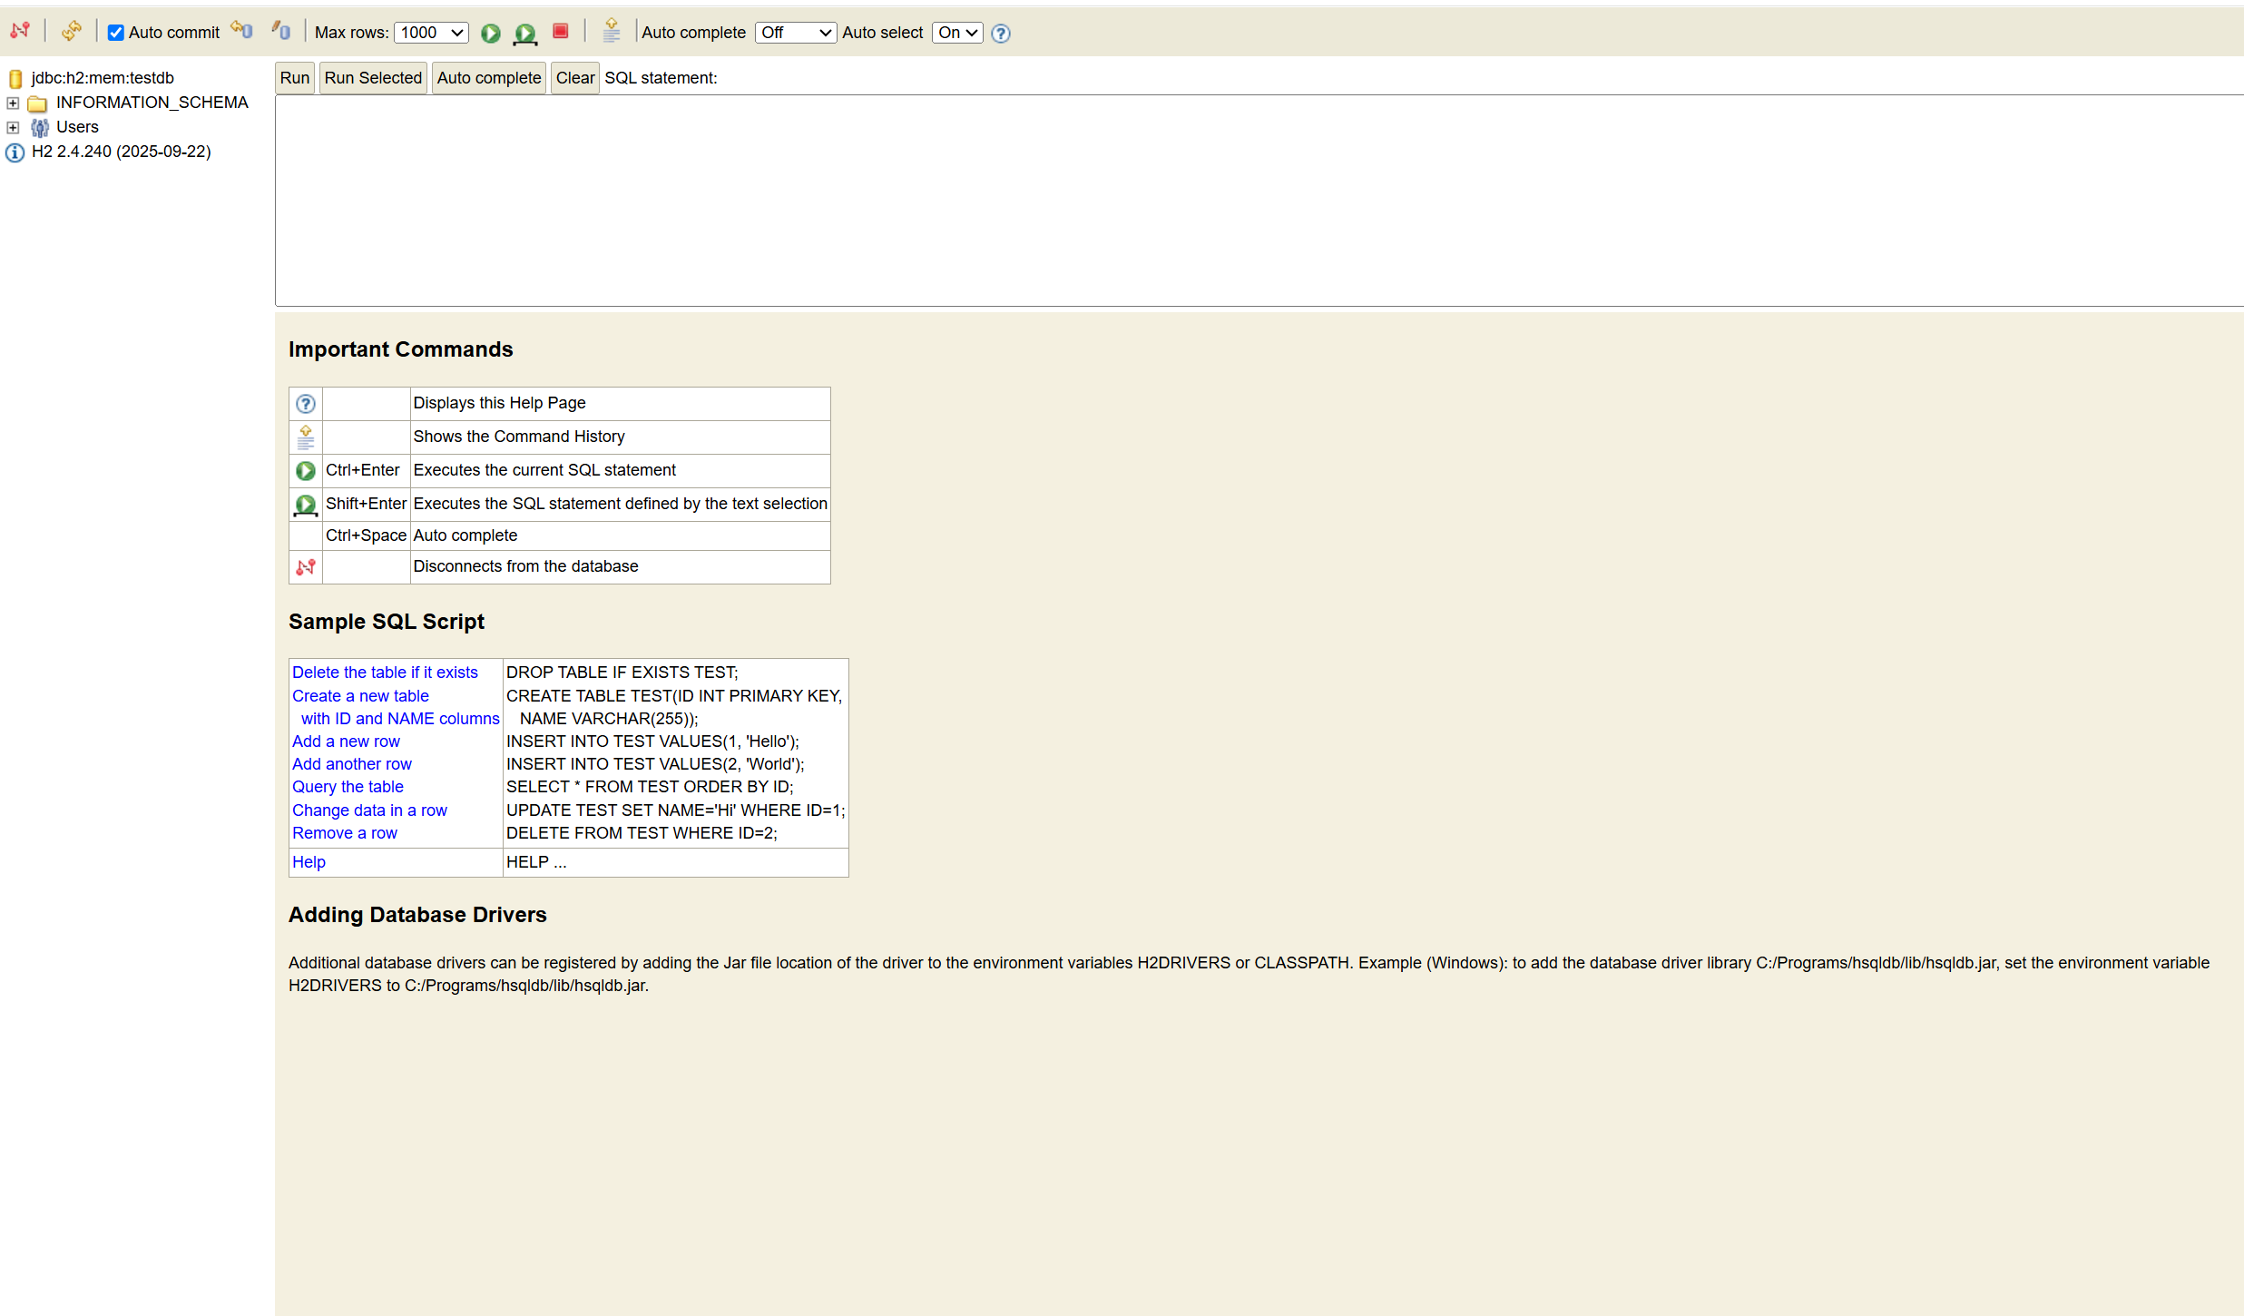
Exercise 2: Employee Management System - Creating Entities
Business Scenario:
Define JPA entities for Employee and Department with appropriate relationships.
Instructions:
- Creating JPA Entities:
  - Define Employee entity with fields: id, name, email, department.
  - Define Department entity with fields: id, name.

- Mapping Entities to Database Tables:
  - Use annotations like @Entity, @Table, @Id, @GeneratedValue, etc.
  - Define one-to-many relationship between Department and Employee.

Exercise 3: Employee Management System - Creating Repositories
Business Scenario:
Create repositories for Employee and Department entities to perform CRUD operations.
Instructions:
- Overview of Spring Data Repositories:
  - Learn the benefits of using Spring Data repositories.
- Creating Repositories:
  - Create EmployeeRepository and DepartmentRepository interfaces extending JpaRepository.
  - Define derived query methods in these repositories.

Output: (ex 2 and ex 3)
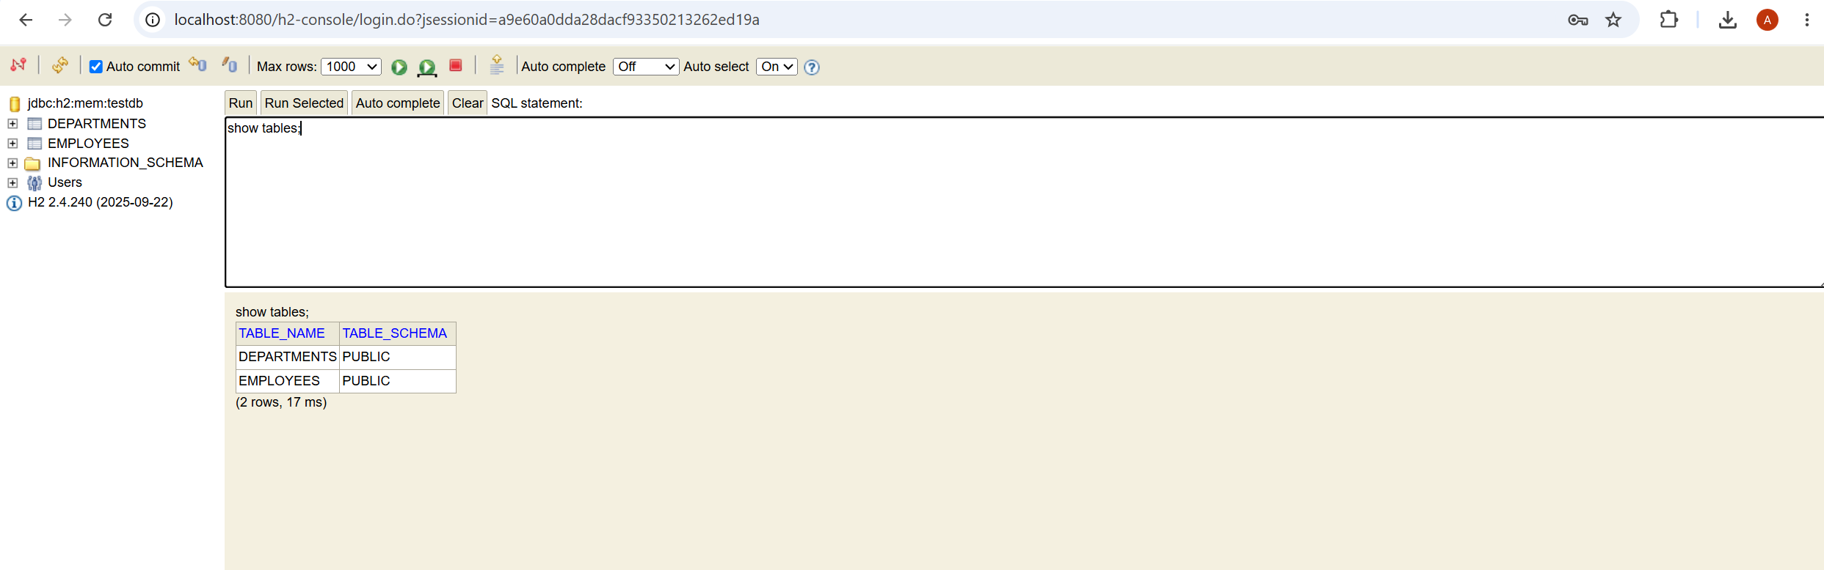

Exercise 4: Employee Management System - Implementing CRUD Operations
Business Scenario:
Implement CRUD operations for managing employees and departments.
Instructions:
- Basic CRUD Operations:
  - Use JpaRepository methods to create, read, update, and delete employees and departments.
  - Implement RESTful endpoints for these operations using EmployeeController and DepartmentController.

Exercise 5: Employee Management System - Defining Query Methods
Business Scenario:
Enhance your repository to support custom queries.
Instructions:
- Defining Query Methods:
  - Use keywords in method names to create custom query methods.
  - Implement custom query methods using the @Query annotation.
- Named Queries:
  - Define and execute named queries with @NamedQuery and @NamedQueries.

Exercise 6: Employee Management System - Implementing Pagination and Sorting
Business Scenario:
Add pagination and sorting capabilities to your employee search functionality.
Instructions:
- Pagination:
  - Implement pagination for the employee list using Page and Pageable.
- Sorting:
  - Add sorting functionality to your queries.
  - Combine pagination and sorting in your search endpoint.

Output: (for 4, 5, 6)

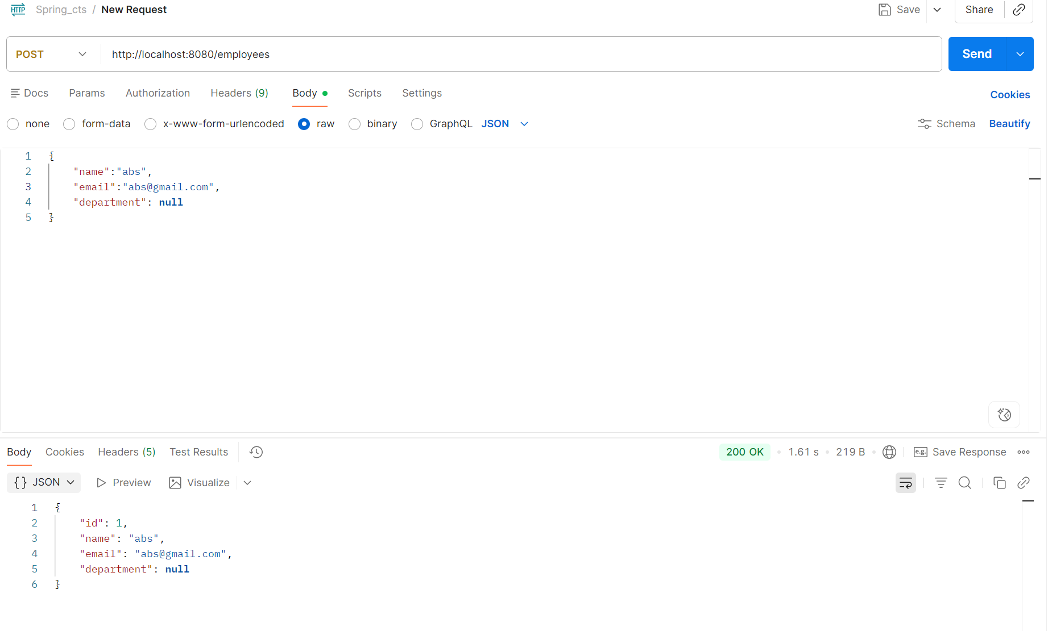



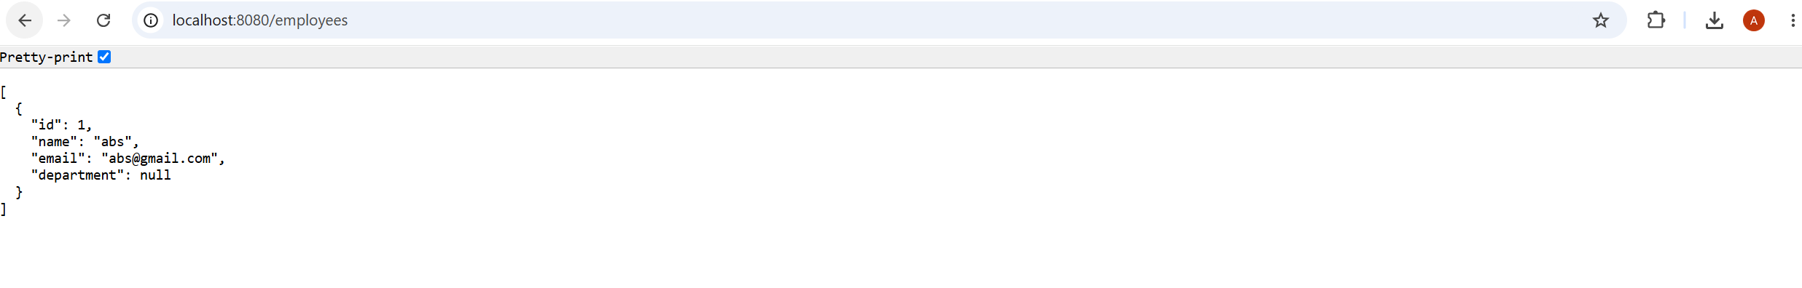
Exercise 7: Employee Management System - Enabling Entity Auditing
Business Scenario:
Implement auditing to track the creation and modification of employees and departments.
Instructions:
- Entity Auditing:
  - Enable auditing in your application by configuring auditing properties.
  - Use annotations like @CreatedBy, @LastModifiedBy, @CreatedDate, and @LastModifiedDate.

Exercise 8: Employee Management System - Creating Projections
Business Scenario:
Create projections to fetch specific data subsets from the employee and department entities.
Instructions:
- Projections:
  - Define interface-based and class-based projections.
  - Use @Value and constructor expressions to control the fetched data.

Exercise 9: Employee Management System - Customizing Data Source Configuration
Business Scenario:
Customize your data source configuration and manage multiple data sources.
Instructions:
- Spring Boot Auto-Configuration:
  - Leverage Spring Boot auto-configuration for data sources.
- Externalizing Configuration:
  - Externalize configuration with application.properties.
  - Manage multiple data sources within your application.

Exercise 10: Employee Management System - Hibernate-Specific Features
Business Scenario:
Leverage Hibernate-specific features to enhance your application's performance and capabilities.
Instructions:
- Hibernate-Specific Annotations:
  - Use Hibernate-specific annotations to customize entity mappings.
- Configuring Hibernate Dialect and Properties:
  - Configure Hibernate dialect and properties for optimal performance.
- Batch Processing:
  - Implement batch processing with Hibernate for bulk operations.

